Block Diagram Reduction
- Blocks in series | 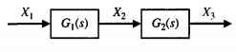  $X_{2}=G_{1}X_{1}$ $≪≫ X_{3}=G_{2}X_{2}$  $X_{3}={G_{1}G}_{2}X_{1}$ | 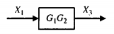
- Parallel blocks | 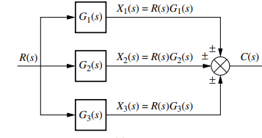 | 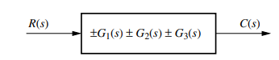
- Moving a summing point ahead of a block | 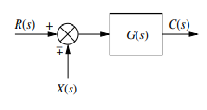  $C\left(s\right)=\left\{R\left(s\right)∓X\left(s\right)\right\}G(s)$ | 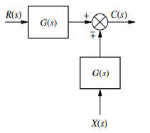  $C\left(s\right)=\left\{R\left(s\right)G(s)∓X\left(s\right)G(s)\right\}$
- Moving a summing point behind of a block | 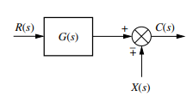  $C\left(s\right)=R\left(s\right)G(s)∓X\left(s\right)$ | 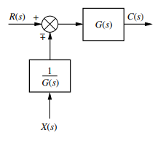  $C\left(s\right)=\left\{R\left(s\right)∓X\left(s\right)\frac{1}{G\left(s\right)}\right\}G(s)$
- Moving a pick off point ahead of a block | 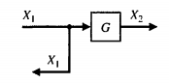 | 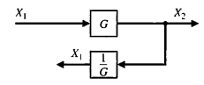  $X_{2}=GX_{1}$ $≪≫ X_{1}=\frac{1}{G}X_{2}$
- Moving a pick off point behind a block | 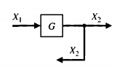  $X_{2}=GX_{1}$ | 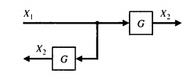
- Reducing a feedback loop | 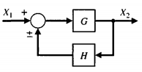  $X_{2}=\left(\frac{G}{1∓GH}\right)X_{2}$ | 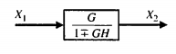

Example 1  Reduce the given block diagram and find the overall transfer function of the system. | 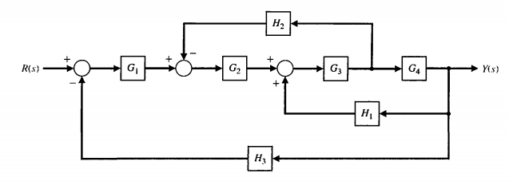
Moving the pickoff point ahead of the block $G_{4}$  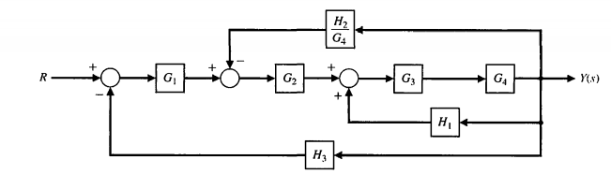 | Combining the series blocks$G_{3}$and $G_{4}$  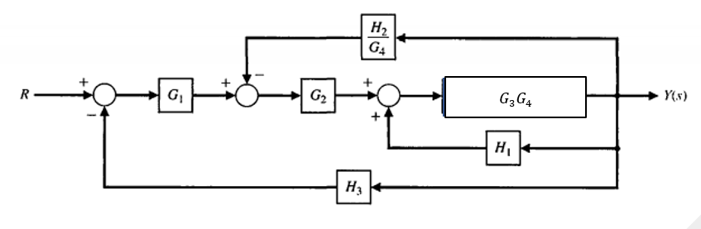
Eliminating the feedback loop  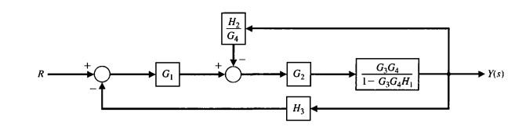 | Combining the series blocks  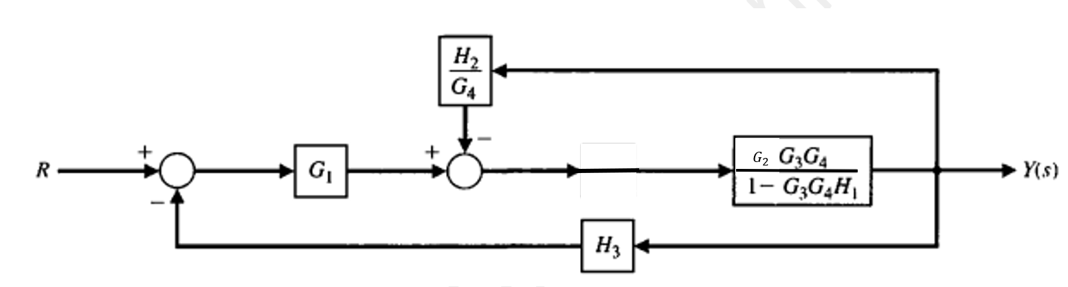
Eliminating the feedback loop  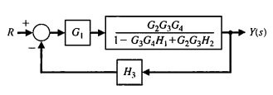 | Combining the series blocks  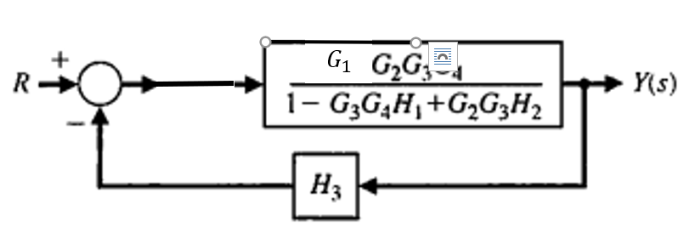
Eliminating the feedback loop
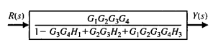

Example 2
Determine the closed loop transfer function $T\left(s\right)=\frac{C(s)}{R(s)}$

Moving the pickoff point ahead of block $G_{3}$ | Combining the series blocks$G_{2}$and $G_{3}$
Eliminating the feedback loop  /1+ | Moving athe pickoff point ahead of the block  /1+
Combining the series block  /1+ | Eliminating the feedback loop  /1+
Eliminating the feed-back loop

Exercise 1  Determie the closed loop transfer function $T\left(s\right)=\frac{Y(s)}{R(s)}$ | 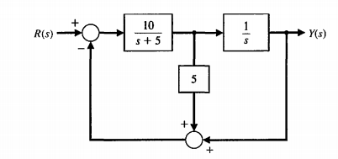
Exercise 2  Determie the closed loop transfer function $T\left(s\right)=\frac{C(s)}{R(s)}$ | 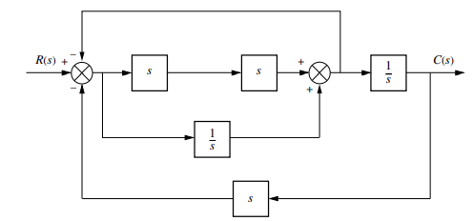
Exercise 3  Determie the closed loop transfer function $T\left(s\right)=\frac{C(s)}{R(s)}$ | 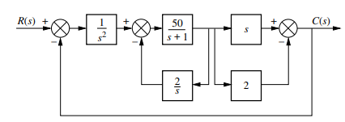
Exercise 4  Determie the closed loop transfer function $T\left(s\right)=\frac{C(s)}{R(s)}$ | 